FREE CLASSROOM RESOURCE

Polynomial Skills Diagnostic Assessment
Short pre-test, 25-question unit diagnostic, and targeted score profile
Algebra I & II | Print-friendly | Classroom diagnostic

Name: ______________________________ | Date: ______________________________
Class / period: ______________________________ | Suggested time: 10 minutes

Directions Complete the short pre-test without notes or a calculator unless your teacher says otherwise. Show enough work to make your method visible. This is a diagnostic, not a grade.

Part 1: Short Polynomial Pre-Test
Use this 10-question check before a unit or tutoring plan. Two questions per skill area is a screen, not a diagnosis, so use the longer assessment when the total is below 7 or the answers are inconsistent.
1. Rewrite 4 - 3x³ + 2x - x² in standard form. Then state the degree and leading coefficient.
________________________________________________________________________________
2. Let p(x) = 2x² - 5x + 1. Find p(-2).
________________________________________________________________________________
3. Simplify (3x² - 4x + 7) + (2x² + x - 5).
________________________________________________________________________________
4. Multiply (x - 3)(x + 5).
________________________________________________________________________________
5. Factor 6x³ - 24x completely.
________________________________________________________________________________

Short Polynomial Pre-Test - Continued
6. Factor 2x² + 7x + 3.
________________________________________________________________________________
7. Divide x³ + 2x² - 5x - 6 by x + 3.
________________________________________________________________________________
8. Find the remainder when p(x) = x³ - 4x + 1 is divided by x - 2.
________________________________________________________________________________
9. List the zeros and multiplicities of f(x) = (x + 1)²(x - 4).
________________________________________________________________________________
10. For g(x) = -2(x + 2)(x - 1)², describe the end behavior and what the graph does at each zero.
________________________________________________________________________________

Pre-Test Quick Score
Foundations 1-2 | Operations 3-4 | Factoring 5-6 | Division 7-8 | Graphs 9-10
___ / 2 | ___ / 2 | ___ / 2 | ___ / 2 | ___ / 2
Use the result 9-10: begin the unit. 7-8: begin with one targeted warm-up. 0-6: use the full diagnostic. A zero in any skill pair is a stronger signal than the total score.

Part 2: Full Polynomial Unit Diagnostic
Name: ______________________________ | Date: ______________________________
Class / period: ______________________________ | Suggested time: 35-45 minutes

Directions Score one point per question. Show work for subtraction, multiplication, factoring, and division so the teacher can separate arithmetic slips from method gaps.

A. Vocabulary, Standard Form, and Evaluation
1. Rewrite 7 - 2x⁴ + 5x² - x in standard form. State the degree, leading coefficient, and constant term.
________________________________________________________________________________
________________________________________________________________________________
2. Classify 3x⁵ - x² + 4 by degree and number of terms.
________________________________________________________________________________
________________________________________________________________________________
3. Circle the expression that is not a polynomial: 4x³ - 2x + 1, 3/x + x², 5, or 2x⁴ - 7x².
________________________________________________________________________________
________________________________________________________________________________
4. For -6x³ + 2x² - 9, state the coefficient of x², the coefficient of x, and the constant term.
________________________________________________________________________________
________________________________________________________________________________
5. Let p(x) = 3x² + x - 4. Find p(-2).
________________________________________________________________________________
________________________________________________________________________________
6. Let q(x) = 4x² - 8x + 3. Find q(1/2).
________________________________________________________________________________
________________________________________________________________________________
7. If f(x) = x² - 3x + 2 and g(x) = 2x + 1, find f(3) + g(-1).
________________________________________________________________________________
________________________________________________________________________________

B. Adding, Subtracting, and Multiplying
8. Add (4x³ - 2x + 5) + (x³ + 6x² + 3x - 8).
________________________________________________________________________________
________________________________________________________________________________
9. Subtract (5x² - 3x + 7) - (2x² + 4x - 1).
________________________________________________________________________________
________________________________________________________________________________
10. Two regions have areas 3x² - 2x + 6 and x² + 5x - 4. Write a polynomial for their total area.
________________________________________________________________________________
________________________________________________________________________________
11. Multiply 3x(2x² - x + 4).
________________________________________________________________________________
________________________________________________________________________________
12. Multiply (x + 6)(x - 2).
________________________________________________________________________________
________________________________________________________________________________
13. Multiply (2x - 3)(x² + x + 4).
________________________________________________________________________________
________________________________________________________________________________
14. Expand (3x - 5)².
________________________________________________________________________________
________________________________________________________________________________

C. Factoring and Polynomial Division
15. Factor 12x⁴ - 18x³.
________________________________________________________________________________
________________________________________________________________________________
16. Factor x² - x - 20.
________________________________________________________________________________
________________________________________________________________________________
17. Factor 6x² + 13x + 6.
________________________________________________________________________________
________________________________________________________________________________
18. Factor 4x³ - 36x completely.
________________________________________________________________________________
________________________________________________________________________________
19. Factor x³ + 2x² - 9x - 18 completely.
________________________________________________________________________________
________________________________________________________________________________
20. Divide 2x³ + 3x² - 11x - 6 by x + 3.
________________________________________________________________________________
________________________________________________________________________________
21. Divide x³ - 5x + 7 by x - 2. Write the quotient and remainder.
________________________________________________________________________________
________________________________________________________________________________
22. Is x - 4 a factor of p(x) = x³ - 6x² + 5x + 12? Show the quickest check.
________________________________________________________________________________
________________________________________________________________________________

D. Zeros and Graphs
23. For f(x) = (x + 3)(x - 1)², list the zeros and state whether the graph crosses or touches at each one.
________________________________________________________________________________
________________________________________________________________________________
________________________________________________________________________________
24. For g(x) = -x³ + 4x, find the zeros and describe the end behavior.
________________________________________________________________________________
________________________________________________________________________________
________________________________________________________________________________
25. Choose the equation whose graph has a zero at -2 where it touches, a zero at 1 where it crosses, and left-down/right-up end behavior: A. (x + 2)²(x - 1), B. -(x + 2)(x - 1)², C. (x + 2)(x - 1), D. -(x + 2)²(x - 1)².
________________________________________________________________________________
________________________________________________________________________________
________________________________________________________________________________

Student Score Profile
Score one point per question. Record section totals before looking at the overall score; the section pattern is what determines the next assignment.
Skill area | Questions | Points | Secure | Developing | Needs work
Foundations | 1-7 | ___ / 7 | 6-7 | 4-5 | 0-3
Operations | 8-14 | ___ / 7 | 6-7 | 4-5 | 0-3
Factoring | 15-19 | ___ / 5 | 4-5 | 3 | 0-2
Division | 20-22 | ___ / 3 | 3 | 2 | 0-1
Zeros and graphs | 23-25 | ___ / 3 | 3 | 2 | 0-1

Overall score: ____ / 25 | Recommended starting assignment: ______________________________

Overall bands 22-25: ready for advanced polynomial work. 18-21: generally ready with targeted review. 13-17: use structured remediation. 0-12: reteach prerequisite skills before a full polynomial unit.

Graph-Matching Remediation Activity
Match each graph to one equation from the bank and one feature description. Use zeros, multiplicity, degree, and leading coefficient; do not rely on the picture alone.
Equation bank - use each equation once
I. y = -(x - 2)²(x + 3)² | II. y = (x + 3)(x - 2)
III. y = (x + 3)²(x - 2) | IV. y = -(x + 3)(x - 2)²
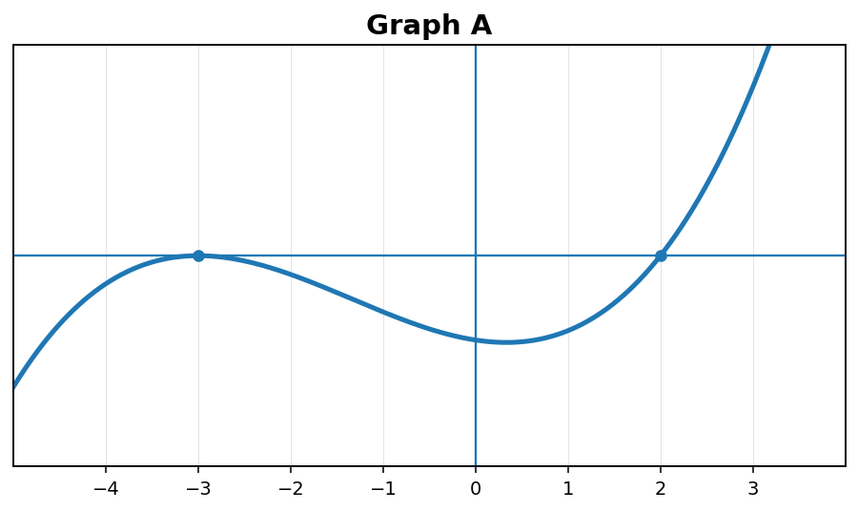 | 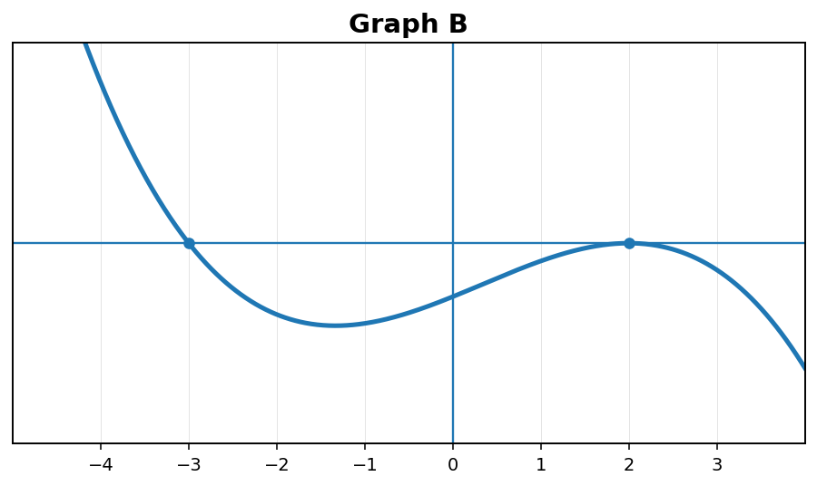
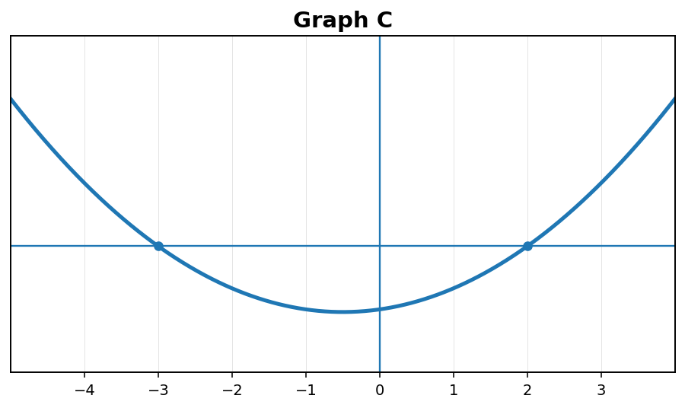 | 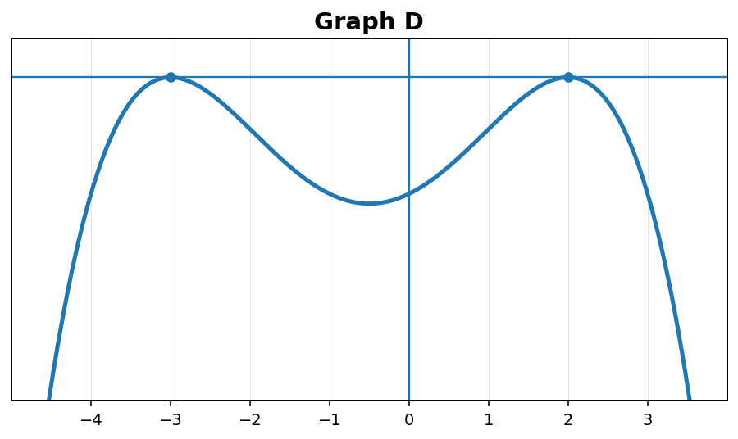
1. Crosses at both x = -3 and x = 2; both ends rise. Graph: ____ Equation: ____
2. Touches at both x = -3 and x = 2; both ends fall. Graph: ____ Equation: ____
3. Crosses at x = -3, touches at x = 2; left up/right down. Graph: ____ Equation: ____
4. Touches at x = -3, crosses at x = 2; left down/right up. Graph: ____ Equation: ____
Explain one match using a zero, multiplicity, and end-behavior statement:
________________________________________________________________________________

