FREE CLASSROOM RESOURCE
Polynomial Error Analysis Worksheet
Find, explain, and correct nine common polynomial mistakes
Algebra I & II | 9 error-analysis cases | Editable teacher file

Name: __________________________ | Date: __________________
Class / period: __________________ | Suggested time: 35-45 minutes
Directions Do not just replace the final answer. Mark the first wrong step, explain the rule in plain language, repair the work, and add one quick check.
The four-step routine
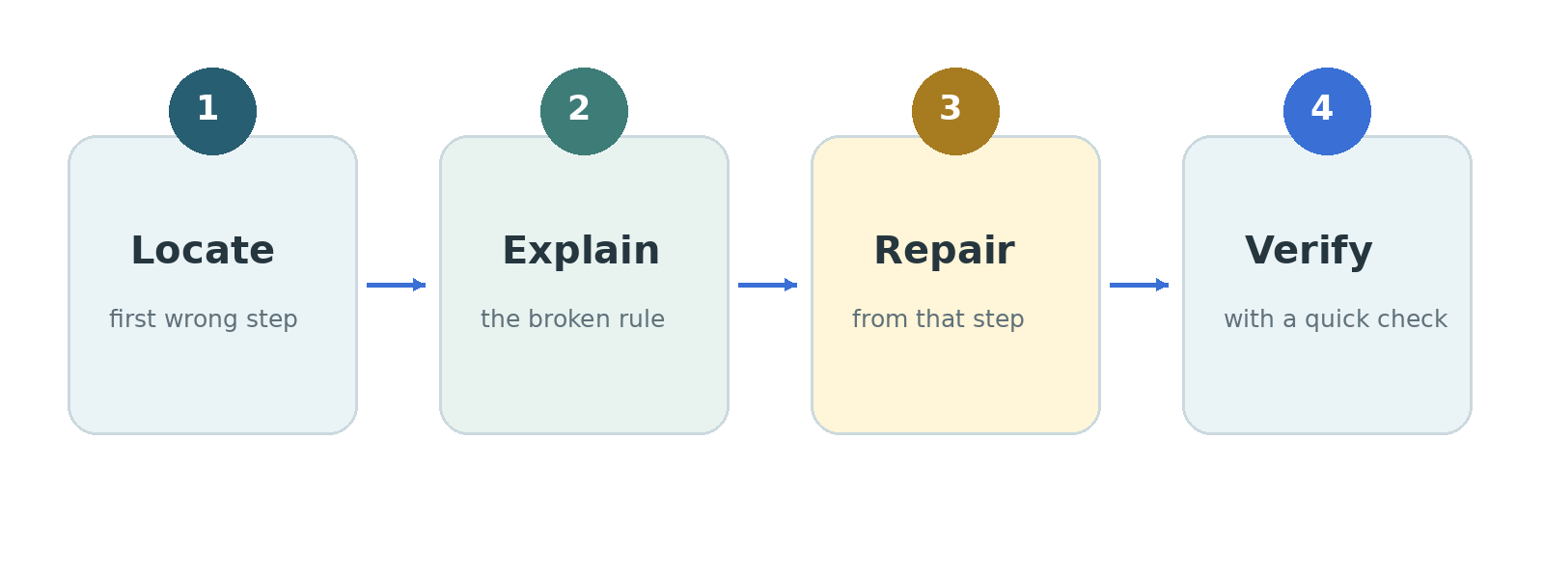
Worked example
Student work: 2x + 5x = 7x²
Correction: The exponent does not change when like terms are combined. The corrected answer is 7x. At x = 3, the original and corrected expressions both equal 21.
Teacher scoring option: 1 point each for location, explanation, correction, and verification. Total: 36 points.

Case 1: Maya - Combining unlike terms
"I combined the x terms. The little powers felt close enough."
Problem: Simplify 3x² + 4x - 5 + 2x² - x + 8.
Maya's work: 3x² + 4x - 5 + 2x² - x + 8
= 5x² + 3x + 3
= 8x³ + 3
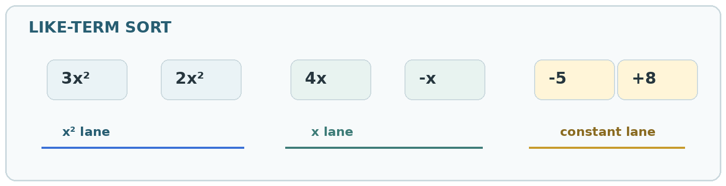
1. Where? Circle the first incorrect step. ________________________________________________
2. Why? State the rule that was used incorrectly. ________________________________________________
3. Fix it. Rewrite the work from the mistake onward. ________________________________________________
4. Check it. Use substitution, multiplication, or graph behavior. ________________________________________________
Case 2: Jordan - Losing a negative sign
"I changed the first sign after the minus. I thought that covered it."
Problem: Subtract (5x² - 2x + 6) - (3x² + 4x - 1).
Jordan's work: (5x² - 2x + 6) - (3x² + 4x - 1)
= 5x² - 2x + 6 - 3x² + 4x - 1
= 2x² + 2x + 5
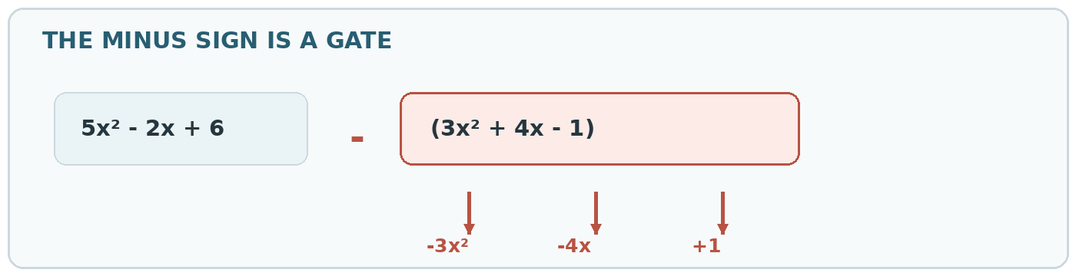
1. Where? Circle the first incorrect step. ________________________________________________
2. Why? State the rule that was used incorrectly. ________________________________________________
3. Fix it. Rewrite the work from the mistake onward. ________________________________________________
4. Check it. Use substitution, multiplication, or graph behavior. ________________________________________________
Case 3: Lena - Distributing exponents incorrectly
"The 2 outside looked like a multiplier, so I doubled the 3."
Problem: Simplify (3x²y)².
Lena's work: (3x²y)² = 6x⁴y²
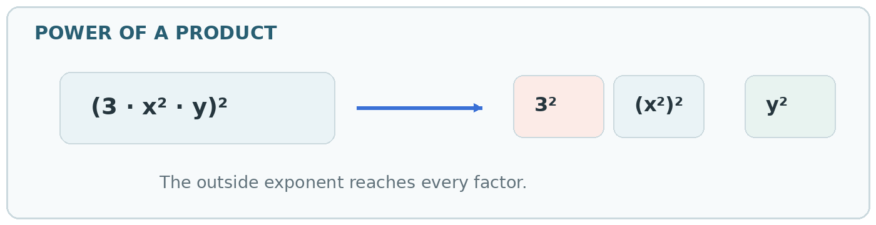
1. Where? Circle the first incorrect step. ________________________________________________
2. Why? State the rule that was used incorrectly. ________________________________________________
3. Fix it. Rewrite the work from the mistake onward. ________________________________________________
4. Check it. Use substitution, multiplication, or graph behavior. ________________________________________________
Case 4: Noah - Using aᵐ + aⁿ = aᵐ⁺ⁿ
"Same base, so I added the exponents. That rule usually works."
Problem: Simplify x³ + x⁵.
Noah's work: x³ + x⁵ = x⁸
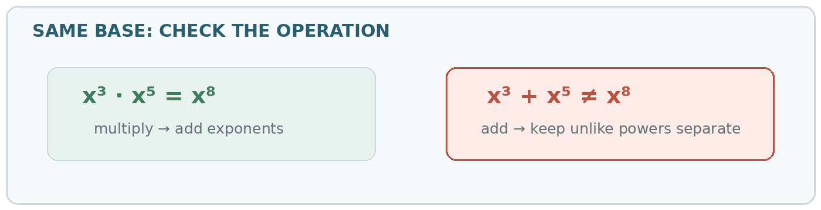
1. Where? Circle the first incorrect step. ________________________________________________
2. Why? State the rule that was used incorrectly. ________________________________________________
3. Fix it. Rewrite the work from the mistake onward. ________________________________________________
4. Check it. Use substitution, multiplication, or graph behavior. ________________________________________________
Case 5: Avery - Forgetting the GCF
"I spotted the squares and went straight to the pattern."
Problem: Factor 18x³ - 50x completely.
Avery's work: 18x³ - 50x
= (3x - 5)(3x + 5)
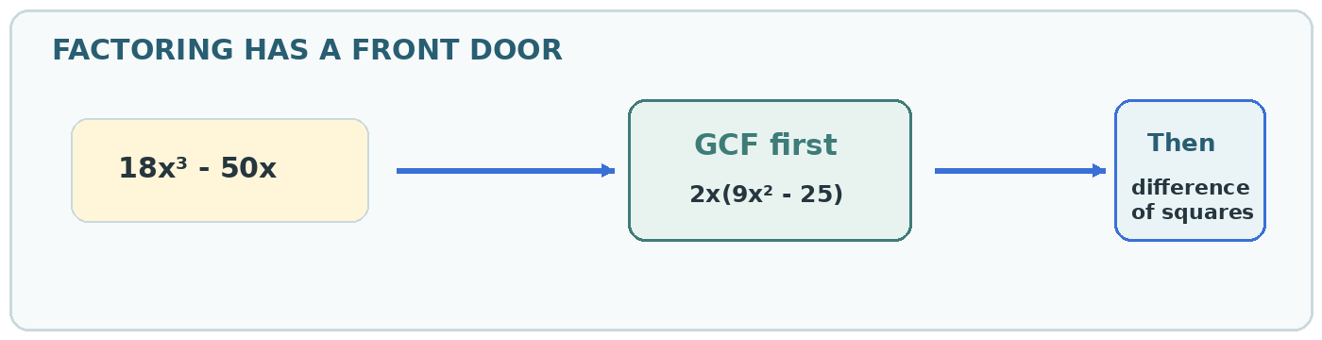
1. Where? Circle the first incorrect step. ________________________________________________
2. Why? State the rule that was used incorrectly. ________________________________________________
3. Fix it. Rewrite the work from the mistake onward. ________________________________________________
4. Check it. Use substitution, multiplication, or graph behavior. ________________________________________________
Case 6: Eli - Incorrect trinomial factors
"The first and last terms checked out. I didn't multiply the middle."
Problem: Factor 6x² + 11x + 3.
Eli's work: 6x² + 11x + 3
= (6x + 1)(x + 3)
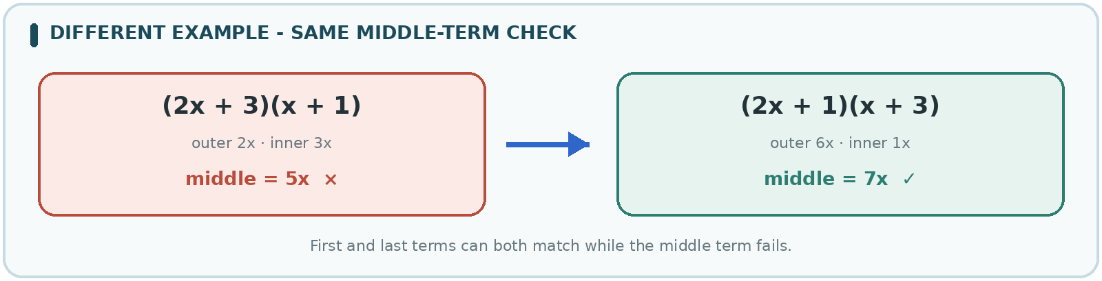
1. Where? Circle the first incorrect step. ________________________________________________
2. Why? State the rule that was used incorrectly. ________________________________________________
3. Fix it. Rewrite the work from the mistake onward. ________________________________________________
4. Check it. Use substitution, multiplication, or graph behavior. ________________________________________________
Case 7: Sofia - Confusing zeros with factors
"I set each factor equal to zero, then copied the signs."
Problem: Find the zeros and multiplicities of f(x) = (x - 4)(x + 1)².
Sofia's work: Zeros: x = -4, multiplicity 1; x = 1, multiplicity 2
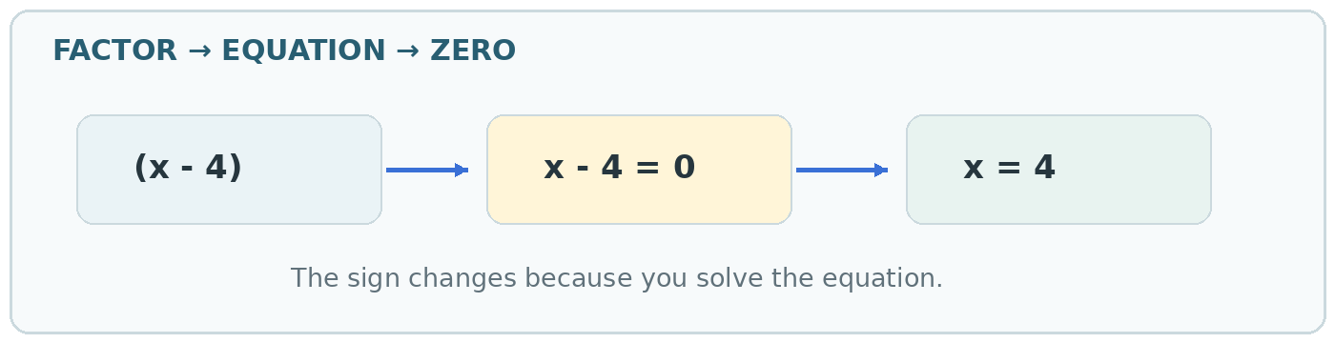
1. Where? Circle the first incorrect step. ________________________________________________
2. Why? State the rule that was used incorrectly. ________________________________________________
3. Fix it. Rewrite the work from the mistake onward. ________________________________________________
4. Check it. Use substitution, multiplication, or graph behavior. ________________________________________________
Case 8: Mateo - Missing placeholders in polynomial division
"No x² term means there's nothing to write there."
Problem: Divide x³ - 4x + 3 by x - 1.
Mateo's work: Synthetic setup: 1 | 1, -4, 3
Result: x - 3
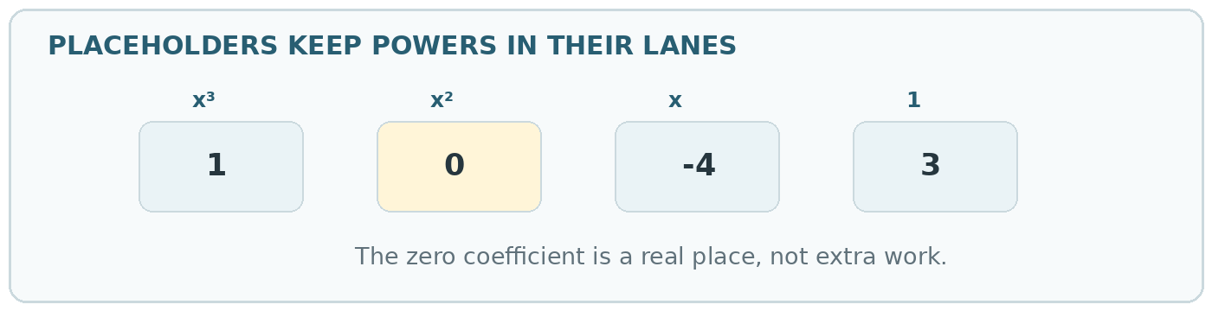
1. Where? Circle the first incorrect step. ________________________________________________
2. Why? State the rule that was used incorrectly. ________________________________________________
3. Fix it. Rewrite the work from the mistake onward. ________________________________________________
4. Check it. Use substitution, multiplication, or graph behavior. ________________________________________________
Case 9: Priya - Incorrect multiplicity behavior
"Both are zeros, so I drew the graph through both."
Problem: Sketch y = (x + 2)²(x - 1).
Priya's work: The sketch crosses the x-axis at x = -2 and x = 1.
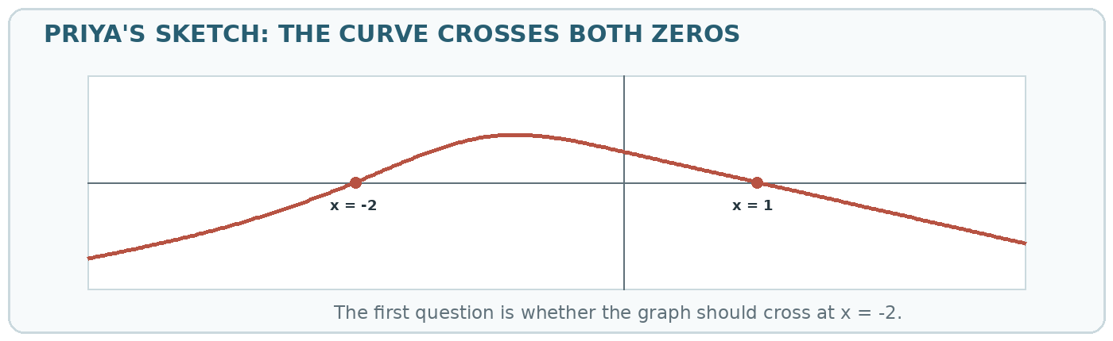
1. Where? Circle the first incorrect step. ________________________________________________
2. Why? State the rule that was used incorrectly. ________________________________________________
3. Fix it. Rewrite the work from the mistake onward. ________________________________________________
4. Check it. Use substitution, multiplication, or graph behavior. ________________________________________________
Pattern reflection
Finish in two sentences: Which kind of mistake is easiest for you to notice? Which check would have caught the hardest mistake sooner?
________________________________________________________________________________
________________________________________________________________________________

TEACHER ANSWER KEY
Polynomial Error Analysis - Teacher Key
Accept equivalent wording, but require the mathematical rule for the explanation point.
Rubric: 1 point locate + 1 point explain + 1 point repair + 1 point verify = 4 points per case.

Case 1: Maya - Combining unlike terms
"I combined the x terms. The little powers felt close enough."
Problem: Simplify 3x² + 4x - 5 + 2x² - x + 8.
Incorrect work: 3x² + 4x - 5 + 2x² - x + 8
= 5x² + 3x + 3
= 8x³ + 3
Where / why: The first incorrect step is combining 5x² and 3x. Their variable parts are different, so they are unlike terms.
Corrected answer: 5x² + 3x + 3
Verification: At x = 2, the original and corrected expressions both equal 29. Maya's 8x³ + 3 equals 67.
Case 2: Jordan - Losing a negative sign
"I changed the first sign after the minus. I thought that covered it."
Problem: Subtract (5x² - 2x + 6) - (3x² + 4x - 1).
Incorrect work: (5x² - 2x + 6) - (3x² + 4x - 1)
= 5x² - 2x + 6 - 3x² + 4x - 1
= 2x² + 2x + 5
Where / why: The subtraction sign must change every sign in the second polynomial, not just the first one.
Corrected answer: 2x² - 6x + 7
Verification: Distribute first: 5x² - 2x + 6 - 3x² - 4x + 1. Then combine like terms.
Case 3: Lena - Distributing exponents incorrectly
"The 2 outside looked like a multiplier, so I doubled the 3."
Problem: Simplify (3x²y)².
Incorrect work: (3x²y)² = 6x⁴y²
Where / why: A power outside parentheses applies as an exponent to every factor. The coefficient must be squared, not doubled.
Corrected answer: 9x⁴y²
Verification: (3x²y)² = 3²(x²)²y² = 9x⁴y².
Case 4: Noah - Using aᵐ + aⁿ = aᵐ⁺ⁿ
"Same base, so I added the exponents. That rule usually works."
Problem: Simplify x³ + x⁵.
Incorrect work: x³ + x⁵ = x⁸
Where / why: Exponents add when powers with the same base are multiplied, not added.
Corrected answer: x³ + x⁵, or x³(1 + x²) in factored form
Verification: At x = 2, x³ + x⁵ = 40, while x⁸ = 256.
Case 5: Avery - Forgetting the GCF
"I spotted the squares and went straight to the pattern."
Problem: Factor 18x³ - 50x completely.
Incorrect work: 18x³ - 50x
= (3x - 5)(3x + 5)
Where / why: The difference-of-squares pattern only accounts for 9x² - 25. The greatest common factor 2x was dropped.
Corrected answer: 2x(3x - 5)(3x + 5)
Verification: Multiplying back gives 2x(9x² - 25) = 18x³ - 50x.
Case 6: Eli - Incorrect trinomial factors
"The first and last terms checked out. I didn't multiply the middle."
Problem: Factor 6x² + 11x + 3.
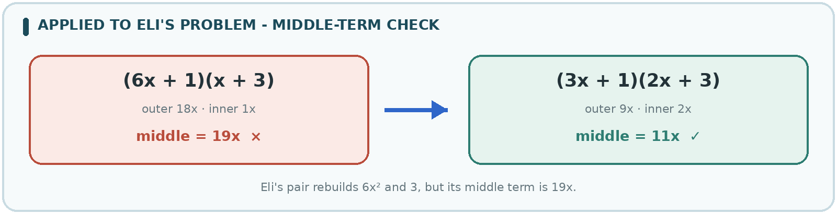
Incorrect work: 6x² + 11x + 3
= (6x + 1)(x + 3)
Where / why: Matching the first and last terms is not enough. The outer and inner products must add to 11x.
Corrected answer: (3x + 1)(2x + 3)
Verification: The correct middle terms are 9x and 2x. They add to 11x.
Case 7: Sofia - Confusing zeros with factors
"I set each factor equal to zero, then copied the signs."
Problem: Find the zeros and multiplicities of f(x) = (x - 4)(x + 1)².
Incorrect work: Zeros: x = -4, multiplicity 1; x = 1, multiplicity 2
Where / why: A zero makes a factor equal to zero. Solving x - 4 = 0 gives x = 4; solving x + 1 = 0 gives x = -1.
Corrected answer: x = 4, multiplicity 1; x = -1, multiplicity 2
Verification: Substitute each zero into the matching factor: 4 - 4 = 0 and -1 + 1 = 0.
Case 8: Mateo - Missing placeholders in polynomial division
"No x² term means there's nothing to write there."
Problem: Divide x³ - 4x + 3 by x - 1.
Incorrect work: Synthetic setup: 1 | 1, -4, 3
Result: x - 3
Where / why: The polynomial has a missing x² term, so its coefficient row must be 1, 0, -4, 3.
Corrected answer: x² + x - 3, remainder 0
Verification: (x - 1)(x² + x - 3) = x³ - 4x + 3.
Case 9: Priya - Incorrect multiplicity behavior
"Both are zeros, so I drew the graph through both."
Problem: Sketch y = (x + 2)²(x - 1).
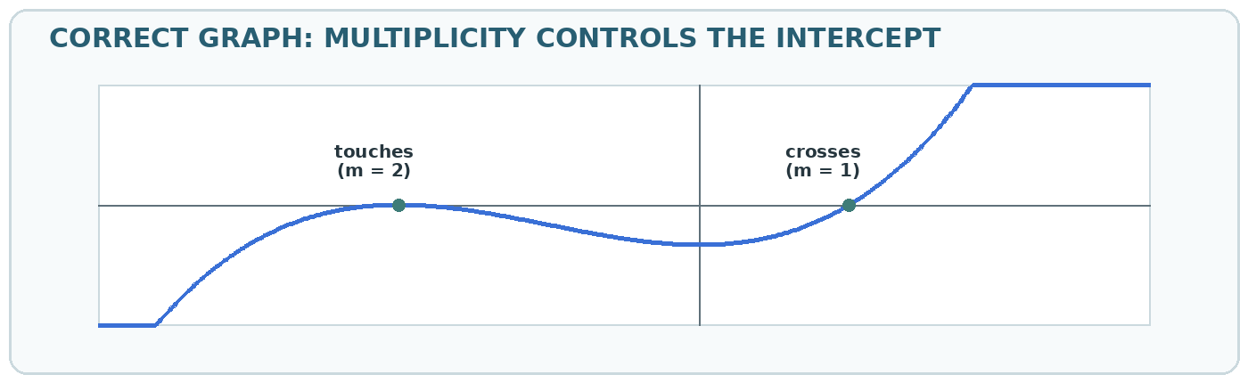
Incorrect work: The sketch crosses the x-axis at x = -2 and x = 1.
Where / why: The zero x = -2 has even multiplicity 2, so the graph touches and turns there. It crosses at x = 1 because that multiplicity is odd.
Corrected answer: Touch at x = -2; cross at x = 1; left end down and right end up.
Verification: The sign stays negative on both sides of x = -2, then changes from negative to positive at x = 1.
Standards and review notes
The activity practices polynomial arithmetic, exponent structure, factoring, the connection between factors and zeros, polynomial division, and graph behavior. It aligns most directly with CCSS HSA.APR.A.1, HSA.APR.B.2, HSA.APR.D.6, and HSF.IF.C.7.c. Every example, correction, and graph was checked before publication on August 3, 2026.
Important limitation: use this classroom-made resource with classwork and local curriculum expectations rather than as a standardized placement test.

